|  |
| --- |
| **LockedMe.com**  **(Application Screenshots)** |

**Version History:**

|  |  |
| --- | --- |
| Author | Vignesh E |
| Purpose | Screenshots of Application |
| Date | 13th Aug 2021 |
| Version | 0.1 Beta |

Contents

1. Main Menu 3

2. List of Files present in folder 3

3. Add New File 4

4. Delete a File 5

5. Search a File 6

# Main Menu

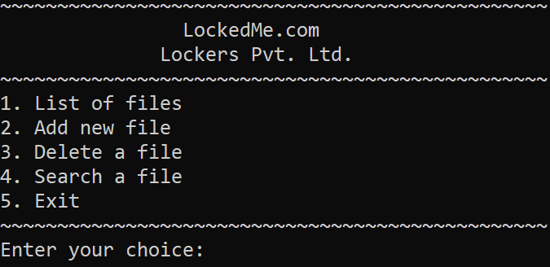

# List of Files present in folder

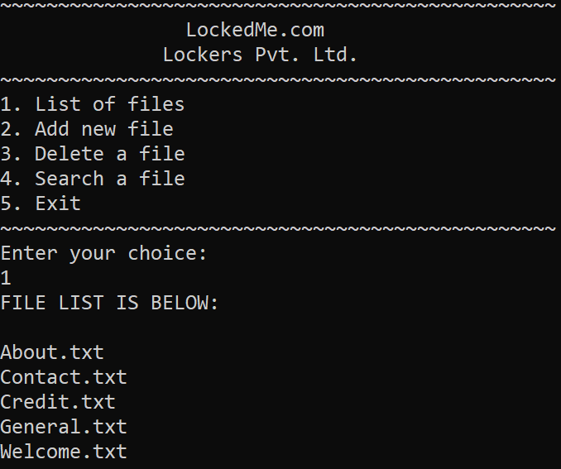

# Add New File

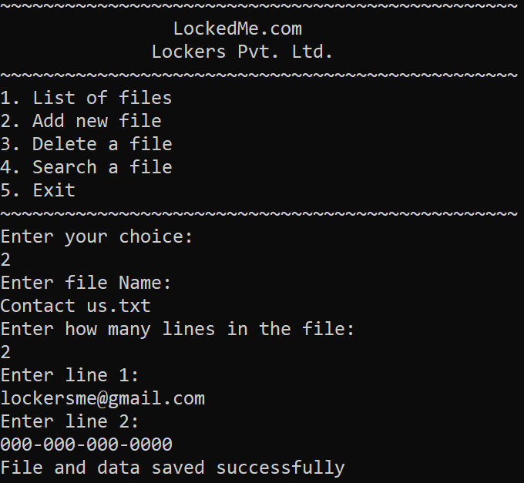

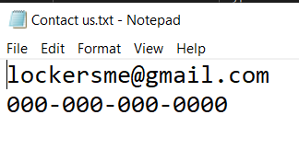

File and Data created successfully in the Directory.

# Delete a File

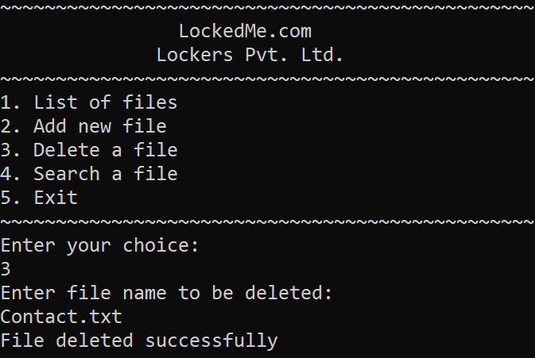

* 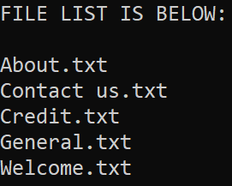Contact.txt file deleted successfully.
* Contact us.txt file added successfully in the directory.

# Search a File

